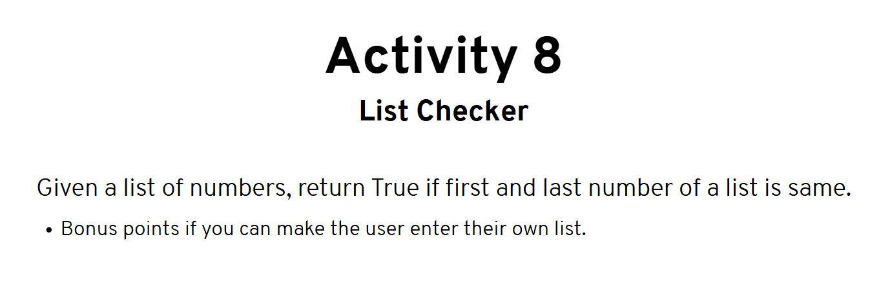

Program:

numList = [10, 20, 30, 40, 10]

print("Given list is ", numList)

firstElement = numList[0]

lastElement = numList[-1]

if (firstElement == lastElement):

print(True)

else:

print(False)

Output:

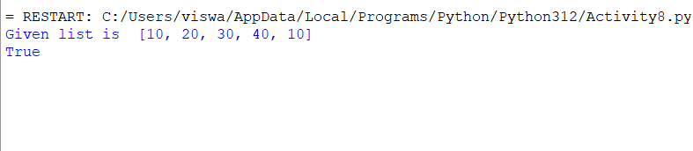

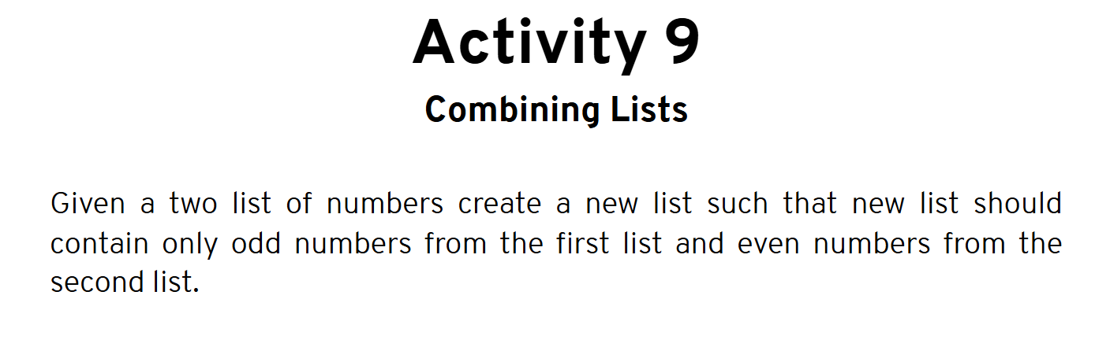

Program:

listOne = [10, 20, 23, 11, 17]

listTwo = [13, 43, 24, 36, 12]

print("First List ", listOne)

print("Second List ", listTwo)

thirdList = []

for num in listOne:

if (num % 2 != 0):

thirdList.append(num)

for num in listTwo:

if (num % 2 == 0):

thirdList.append(num)

print("result List is:")

print(thirdList)

Output:

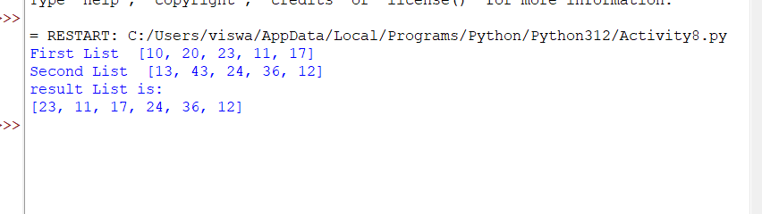

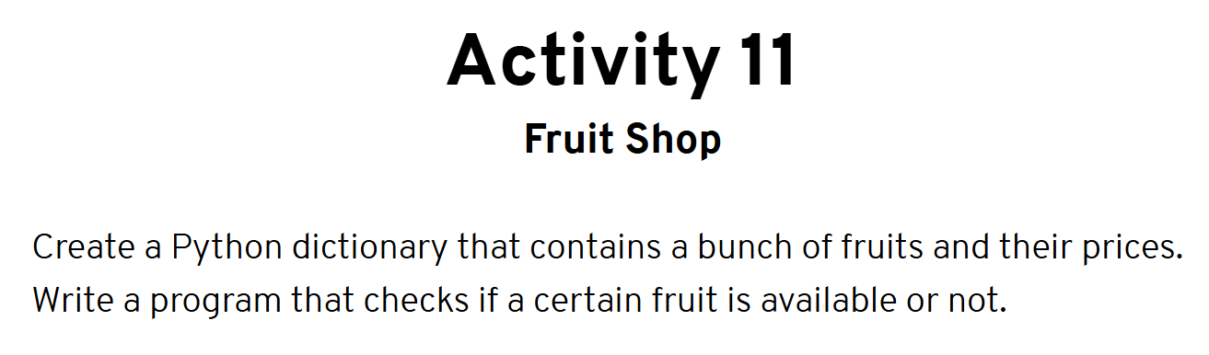

Program:

fruit_shop = {

"apple": 10,

"banana": 15,

"orange": 8,

"peaches": 15

}

key_to_check = input("Which fruit do u wanna search? ").lower()

if(key_to_check in fruit_shop):

print("Yes, this is available")

else:

print("No, this is not available")

Output:

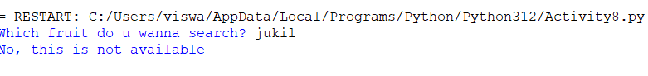

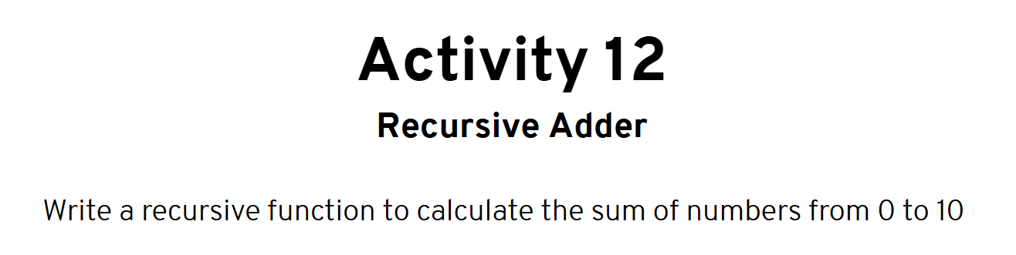

Program:

def calSum(num):

if num:

return num + calSum(num-1)

else:

return 0

res = calSum(10)

print(res)

Output:

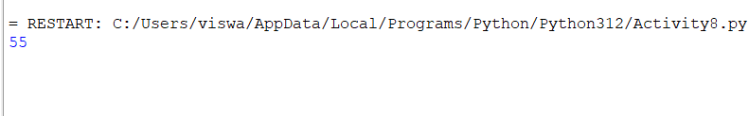

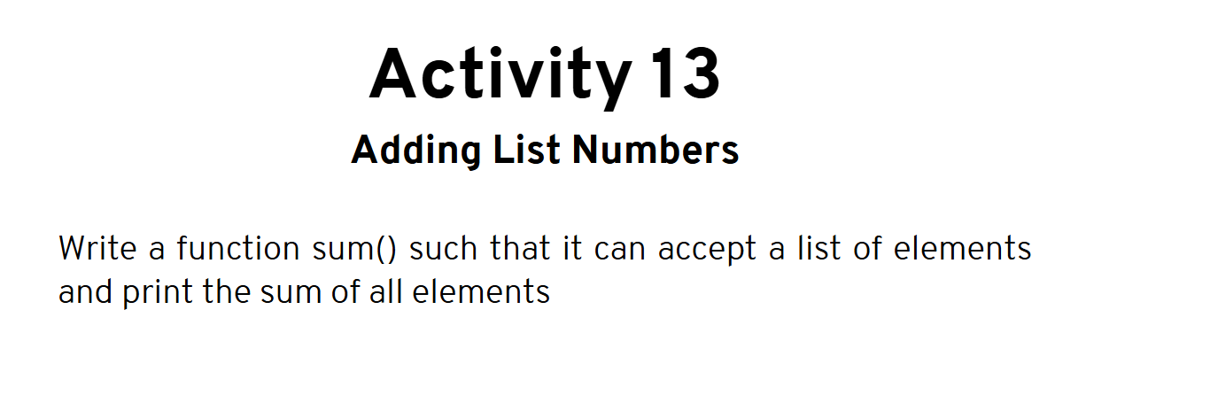

**Program:**

def cal_sum(numbers):

sum = 0

for number in numbers:

sum += number

return sum

numList = [10, 40, 60, 90]

result = cal_sum(numList)

print("The sum of all the elements is: " + str(result))

**Output:**



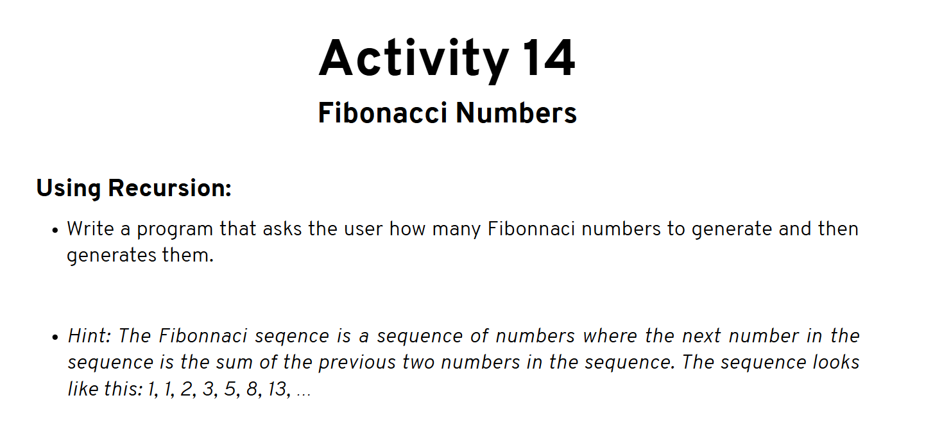**Program:**

def fibonacci(number):

if number <= 1:

return number

else:

return(fibonacci(number-1) + fibonacci(number-2))

nterms = int(input("Enter a number: "))

if nterms <= 0:

print("Please enter a positive number")

else:

print("Fibonacci Sequence: ")

for i in range(nterms):

print(fibonacci(i))

**Output:**

